INSERT INTO Wards (Id, Description, RoomNr)

VALUES

(NEWID(), 'Cardiology Ward', 101),

(NEWID(), 'Orthopedics Ward', 202),

(NEWID(), 'Neurology Ward', 303),

(NEWID(), 'Oncology Ward', 404),

(NEWID(), 'Pediatrics Ward', 505),

(NEWID(), 'Dermatology Ward', 606),

(NEWID(), 'Gynecology Ward', 707),

(NEWID(), 'Urology Ward', 808),

(NEWID(), 'Psychiatry Ward', 909),

(NEWID(), 'Surgery Ward', 1010);

INSERT INTO Hospitals (Id, Name, Address)

VALUES

(NEWID(), 'Hospital A', '123 Main Street'),

(NEWID(), 'Hospital B', '456 Oak Avenue'),

(NEWID(), 'Hospital C', '789 Pine Boulevard'),

(NEWID(), 'Hospital D', '101 Maple Drive'),

(NEWID(), 'Hospital E', '202 Cedar Lane'),

(NEWID(), 'Hospital F', '303 Elm Circle'),

(NEWID(), 'Hospital G', '404 Pine Trail'),

(NEWID(), 'Hospital H', '505 Oak Grove'),

(NEWID(), 'Hospital I', '606 Maple Park'),

(NEWID(), 'Hospital J', '707 Cedar Square');

INSERT INTO Patients (Id, Name, DateOfBirth, Phone, Email, Address, Description, WardId)

VALUES

(NEWID(), 'John Doe', '1985-07-15', '555-1234', 'john.doe@example.com', '123 Main St', 'Description for John Doe', (SELECT TOP 1 Id FROM Wards ORDER BY NEWID())),

(NEWID(), 'Jane Smith', '1990-03-25', '555-5678', 'jane.smith@example.com', '456 Oak St', 'Description for Jane Smith', (SELECT TOP 1 Id FROM Wards ORDER BY NEWID())),

(NEWID(), 'Michael Johnson', '1988-11-03', '555-7890', 'michael.johnson@example.com', '789 Pine St', 'Description for Michael Johnson', (SELECT TOP 1 Id FROM Wards ORDER BY NEWID())),

(NEWID(), 'Sarah Williams', '1982-09-12', '555-2345', 'sarah.williams@example.com', '101 Maple Ave', 'Description for Sarah Williams', (SELECT TOP 1 Id FROM Wards ORDER BY NEWID())),

(NEWID(), 'David Brown', '1987-07-18', '555-6789', 'david.brown@example.com', '202 Cedar Dr', 'Description for David Brown', (SELECT TOP 1 Id FROM Wards ORDER BY NEWID())),

(NEWID(), 'Jessica Davis', '1989-02-02', '555-0123', 'jessica.davis@example.com', '303 Pine Ln', 'Description for Jessica Davis', (SELECT TOP 1 Id FROM Wards ORDER BY NEWID())),

(NEWID(), 'Mark Wilson', '1983-06-30', '555-3456', 'mark.wilson@example.com', '404 Oak Cir', 'Description for Mark Wilson', (SELECT TOP 1 Id FROM Wards ORDER BY NEWID())),

(NEWID(), 'Laura Miller', '1984-04-17', '555-8901', 'laura.miller@example.com', '505 Maple Blvd', 'Description for Laura Miller', (SELECT TOP 1 Id FROM Wards ORDER BY NEWID())),

(NEWID(), 'Brian Jackson', '1981-12-25', '555-4567', 'brian.jackson@example.com', '606 Cedar Ave', 'Description for Brian Jackson', (SELECT TOP 1 Id FROM Wards ORDER BY NEWID())),

(NEWID(), 'Rachel Taylor', '1986-08-08', '555-7890', 'rachel.taylor@example.com', '707 Cedar Square', 'Description for Rachel Taylor', (SELECT TOP 1 Id FROM Wards ORDER BY NEWID()));

INSERT INTO Stays (Id, StartDate, EndDate, Reason, PatientId)

VALUES

(NEWID(), '2022-01-01', '2022-01-10', 'Recovery', (SELECT TOP 1 Id FROM Patients ORDER BY NEWID())),

(NEWID(), '2022-02-05', '2022-02-15', 'Observation', (SELECT TOP 1 Id FROM Patients ORDER BY NEWID())),

(NEWID(), '2022-03-10', '2022-03-20', 'Surgery', (SELECT TOP 1 Id FROM Patients ORDER BY NEWID())),

(NEWID(), '2022-04-15', '2022-04-25', 'Treatment', (SELECT TOP 1 Id FROM Patients ORDER BY NEWID())),

(NEWID(), '2022-05-20', '2022-05-30', 'Rehabilitation', (SELECT TOP 1 Id FROM Patients ORDER BY NEWID())),

(NEWID(), '2022-06-25', '2022-07-05', 'Observation', (SELECT TOP 1 Id FROM Patients ORDER BY NEWID())),

(NEWID(), '2022-07-30', '2022-08-09', 'Surgery', (SELECT TOP 1 Id FROM Patients ORDER BY NEWID())),

(NEWID(), '2022-08-01', '2022-08-11', 'Treatment', (SELECT TOP 1 Id FROM Patients ORDER BY NEWID())),

(NEWID(), '2022-09-05', '2022-09-15', 'Rehabilitation', (SELECT TOP 1 Id FROM Patients ORDER BY NEWID())),

(NEWID(), '2022-10-10', '2022-10-20', 'Observation', (SELECT TOP 1 Id FROM Patients ORDER BY NEWID()));

INSERT INTO Departments (Id, DepartmentName, DepartmentType, Description)

VALUES

(NEWID(), 'Department 1', 'Type A', 'Description for Department 1'),

(NEWID(), 'Department 2', 'Type B', 'Description for Department 2'),

(NEWID(), 'Department 3', 'Type C', 'Description for Department 3 (Invalid)'),

(NEWID(), 'Department 4', 'Type D', 'Description for Department 4 (Invalid)'),

(NEWID(), 'Department 5', 'Type E', 'Description for Department 5'),

(NEWID(), 'Department 6', 'Type F', 'Description for Department 6'),

(NEWID(), 'Department 7', 'Type G', 'Description for Department 7'),

(NEWID(), 'Department 8', 'Type H', 'Description for Department 8'),

(NEWID(), 'Department 9', 'Type I', 'Description for Department 9'),

(NEWID(), 'Department 10', 'Type J', 'Description for Department 10');

INSERT INTO Doctors (Id, Name, DateOfBirth, HireDate, Phone, Email, Salary, Address, DepartmentId)

VALUES

(NEWID(), 'Dr. John Doe', '1978-03-15', '2010-05-20', '555-1234', 'john.doe@example.com', 120000, '123 Main St', (SELECT TOP 1 Id FROM Departments ORDER BY NEWID())),

(NEWID(), 'Dr. Jane Smith', '1980-05-25', '2015-08-10', '555-5678', 'jane.smith@example.com', 130000, '456 Oak St', (SELECT TOP 1 Id FROM Departments ORDER BY NEWID())),

(NEWID(), 'Dr. Michael Johnson', '1975-11-13', '2012-09-30', '555-7890', 'michael.johnson@example.com', 110000, '789 Pine St', (SELECT TOP 1 Id FROM Departments ORDER BY NEWID())),

(NEWID(), 'Dr. Sarah Williams', '1982-09-12', '2014-06-05', '555-2345', 'sarah.williams@example.com', 125000, '101 Maple Ave', (SELECT TOP 1 Id FROM Departments ORDER BY NEWID())),

(NEWID(), 'Dr. David Brown', '1977-07-18', '2016-10-25', '555-6789', 'david.brown@example.com', 118000, '202 Cedar Dr', (SELECT TOP 1 Id FROM Departments ORDER BY NEWID())),

(NEWID(), 'Dr. Jessica Davis', '1979-02-02', '2011-04-05', '555-0123', 'jessica.davis@example.com', 135000, '303 Pine Ln', (SELECT TOP 1 Id FROM Departments ORDER BY NEWID())),

(NEWID(), 'Dr. Mark Wilson', '1974-06-30', '2013-12-20', '555-3456', 'mark.wilson@example.com', 115000, '404 Oak Cir', (SELECT TOP 1 Id FROM Departments ORDER BY NEWID())),

(NEWID(), 'Dr. Laura Miller', '1973-04-17', '2017-02-28', '555-8901', 'laura.miller@example.com', 128000, '505 Maple Blvd', (SELECT TOP 1 Id FROM Departments ORDER BY NEWID())),

(NEWID(), 'Dr. Brian Jackson', '1981-12-25', '2018-06-15', '555-4567', 'brian.jackson@example.com', 118000, '606 Cedar Ave', (SELECT TOP 1 Id FROM Departments ORDER BY NEWID())),

(NEWID(), 'Dr. Rachel Taylor', '1986-08-08', '2019-09-10', '555-7890', 'rachel.taylor@example.com', 132000, '707 Cedar Square', (SELECT TOP 1 Id FROM Departments ORDER BY NEWID()));

select \* from Wards

select \* from Departments

select \* from Patients

select \* from Stays

select \* from Doctors

Pilt:

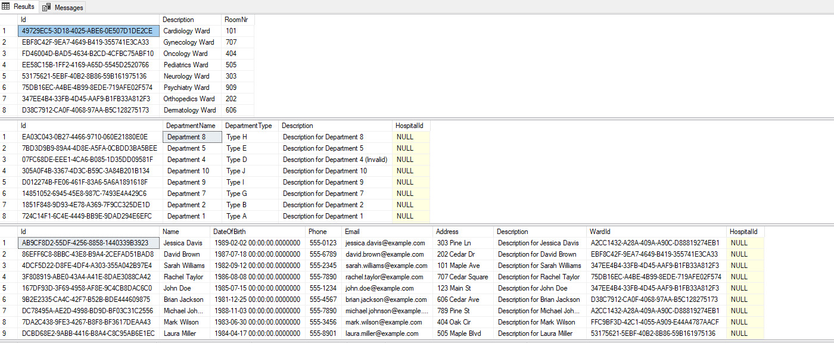

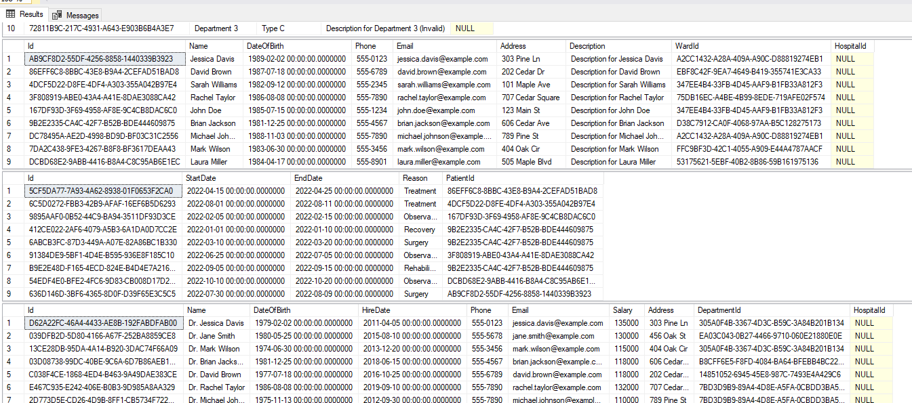

Kood:

CREATE PROCEDURE GetPatientsInDepartment2

@DepartmentName NVARCHAR(50)

AS

BEGIN

SELECT Patients.\*

FROM Patients

JOIN Wards ON Patients.WardId = Wards.Id

JOIN Departments ON Wards.ID = Departments.Id

WHERE Departments.DepartmentName = @DepartmentName;

END;

Pilt:

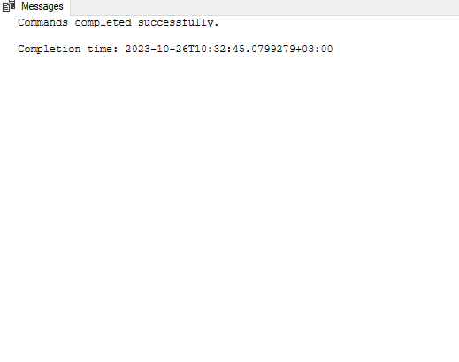

Kood:

SELECT Patients.Name, Wards.Description

FROM Patients

JOIN Wards ON Patients.WardId = Wards.Id;

Pilt:

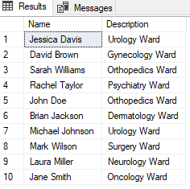

Kood:

SELECT Patients.Name, Stays.StartDate

FROM Patients

LEFT JOIN Stays ON Patients.Id = Stays.PatientId;

Pilt:

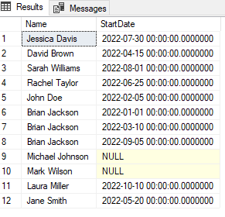

Kood:

SELECT Patients.Name, Doctors.Name

FROM Patients

CROSS JOIN Doctors;

Pilt:

